16. Scenario: You are working on a project that involves analyzing customer reviews for a product.

You have a dataset containing customer reviews, and your task is to develop a Python program that

calculates the frequency distribution of words in the reviews.

Question: Develop a Python program to calculate the frequency distribution of words in the

customer reviews dataset?

**CODE:**

import pandas as pd

from collections import Counter

import re

file_path =r"C:\Users\Shashankbheemavarapu\Downloads\customer_reviews.csv"

df = pd.read_csv(file_path)

all_reviews = " ".join(df["Review"])

cleaned_text = re.sub(r"[^\w\s]", "", all_reviews).lower()

words = cleaned_text.split()

word_frequency = Counter(words)

print("Word Frequency Distribution:")

for word, freq in word_frequency.items():

print(f"{word}: {freq}")

**OUTPUT:**

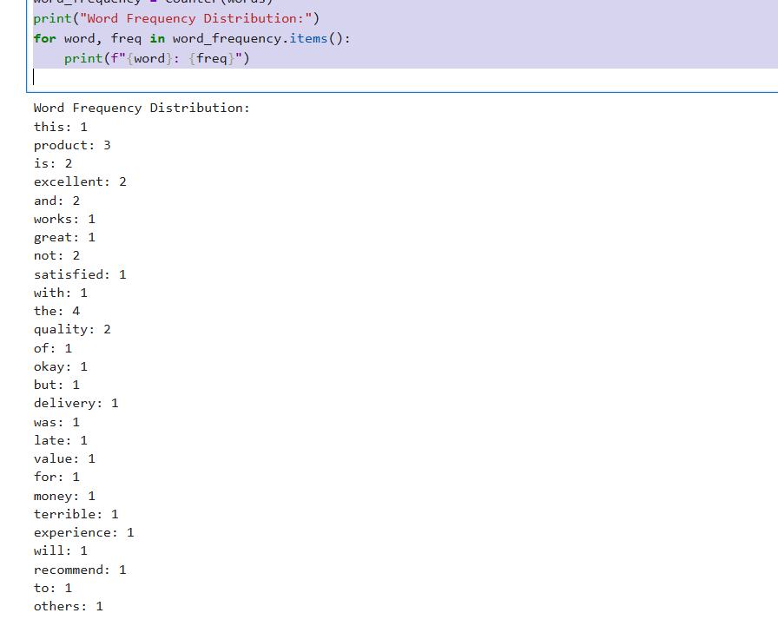

**DATASET:**

|  |
| --- |
| Review |
| This product is excellent and works great! |
| Not satisfied with the quality of the product. |
| The product is okay, but the delivery was late. |
| Excellent quality and value for money. |
| Terrible experience, will not recommend to others. |